**Game Overview – “How much Kannya eat?” – Tomasz Galka**

**Game Name: How much Kannya eat?**

**Target Audience:** Players that enjoy a competitive collect-a-thon. 12+.

**Genre:** Exploration, Collection

**Developer:** Tomasz Galka

**Idea Overview**

My idea for the game is a simple collect-a-thon around a futuristic, procedurally generated city but with a twist. The objective will be to collect (eat or catch) crabs and insects around the map. Eating insects requires more time but will reward the player with more points. Possibility of multiplayer with a race mode.

**Gameplay**

You play as a **Dragon-girl** that is hungry. Your objective is to navigate yourself around a futuristic city, finding food in the form of crabs and insects. The collectibles will have different randomly generated rarity level which will determine the amount of food they replenish and the amount of points they grant. You can either catch them with a net and eat them later or eat the immediately for a point bonus. The point system will be simple, eater or collecting will grant points to the player based on the rarity of the catch. The eating will give less points but is faster than catching. There will be an inventory system in place with a limited amount of storage for caught targets.

There will be two main resources; health and hunger. If hunger goes below a certain amount, the player will start losing health slowly. Hunger is replenished by eating instantly or eating previously caught food from the inventory for a small hunger penalty. Health will not be able to be replenished by food, but occasionally power ups may spawn around the map granting the player a heal.

Due to the random nature of the city generation, the game will provide players with unique levels which they can freely explore with cheats, otherwise they might die of hunger and lose the game if they don’t eat for a certain amount of time. These variables will be determined when building the game.

**Score System**

The score system will be simple but effective. Based on what the player’s have caught and how, they’ll receive a set amount of “Moe *Points”*, increasing based on the food’s rarity level. Catching food with the net takes longer but allows you to store it for later if for some reason you are unable to find food and your hunger is low. This will come with a health and food replenishment penalty but will prove useful later on in the game. Immediately eating food grants the food’s full hunger replenishment value and is faster, but it grants less *Moe Points.*

**Game End**

The only way for the game to end is for the player to lose enough hunger for their health to go down to zero. When the game ends, a screen will be shown; displaying the player’s score, amount of food eaten, amount of food collected and time alive as well as the player’s local high score.

**Analytics**

To track user interaction and other variables, the game will feature analytics through the use of Unity’s built-in analytics system through the use of **Custom Events** via the Unity Analytics API. This will help me track the progress of everyone that has played the game and based on the data determine if there’s any changes that need to be made.

**Narrative**

The only narrative this game will feature will be a possible start game cutscene explaining the short story.

**MDA Summary**

**Mechanics:** Collection of randomly generated food around a procedurally generated city. Choice of action dilemma. Player has to determine what action would be smart to take. (eating or catching)Players will need to keep their hunger high in order to survive.

**Dynamics:** The player will feel restricted and pressured due to the hunger resource. The pressure of sustaining a certain amount of hunger/health can make the players feel nervous. Players may also panic when the resources are low if they wish to set a good score.

**Aesthetics:** The city structures will be textured to fit the other models. Most important models (player and potential food) will have animations and lights. If there is time, the player will be able to be customized to a certain extent.

**Generation Logic Overview**

The world will be procedurally generated using a custom procedural generation system. When the world is generated, *relevant* sectors of the map will be marked. These sectors will be marked based on two simple rules:

* The selected sector must be on either a **road, road corner or path** tile.
* The selector sector cannot be next to any other sector in any direction. Each sector must be at least two tiles away. This will prevent the map from being overfilled with potential food, making the game too easy and not enjoyable.

These *relevant sectors* will be used to determine where each piece of food can or can’t spawn.

**Multiplayer**

If implemented, the multiplayer will consist of multiple dragons competing against each other in finding food for themselves. Unlike single player, multiplayer will be timed. Last player standing wins. The rarity of food will increase as time goes on. It will be played with up to 6 people as a **P2P** game.

**Possible Development Difficulties**

* Creating a smooth animation for both the player and food will be a challenging task.
* Adding multiplayer may prove to be difficult.
* Generating the correct types of world may also be difficult however it is required therefore most of the time will be spent on this.
* The amount of time we have to make this game will be a very evident limiting factor.

**Controls**

Simple **WASD** movement for the character and **mouse** movement for the camera. The character will move towards the direction of the camera. **E** to collect (player will be prompted to either eat instantly or catch). When collected, a prompt will appear asking the player which action they will want to take). The **TAB** key by default will serve as the inventory key. The keys for **Interaction, Jumping and Inventory** will all be rebind able in the options. The **sensitivity** of the camera and the **axis reversal** will also be changeable. The camera will also be zoomable with the use of the **Mouse Scroll Wheel**.

**Story**

The **Dragon** was left home alone and was fine with it… until she opened the fridge and found that there was no food left in the house. Starving and armed with her net; she set off into the city, searching far and wide for food to keep her going for the day.

**Extra Optional Features**

These features are **optional** and might or might not be implemented based on whether there is some extra time left to implement these over the development cycle of this game:

* Character customizability through vanity items such as hats and colour changes.
* Timed mode.
* Local leader boards.

**Other Ideas**

* Multiplayer racing game across a procedurally generated futuristic city, avoiding obstacles and racing to the finish. Game would include powerups which give players the upper hand.
  + I rejected this idea due to the dependency on multiplayer.
* First-Person Single player/Multiplayer Shooter around a procedurally generated city.
  + I rejected this idea due to the sheer work that would have to be put into the weapons and backend of the game for it to be enjoyable.

**Sketches**

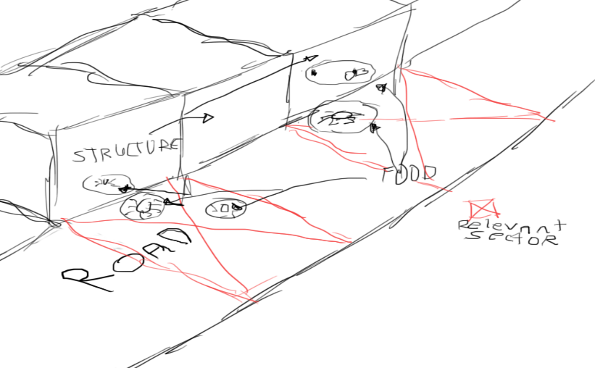

*Relevant sector and food mechanic sketch along with structures and roads.*

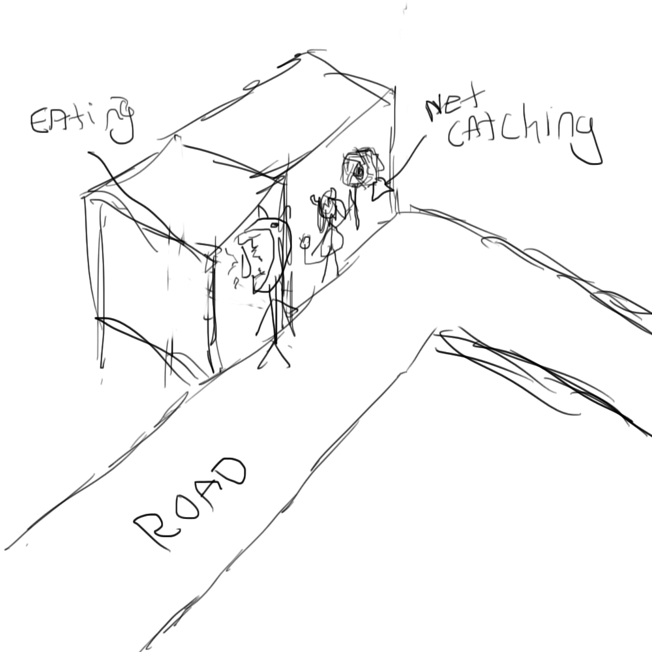

*Sketch of the eating and net catching mechanic. The eating animation will make the player model walk up to the target and bite it and the net animation will just swing a net at the target.*

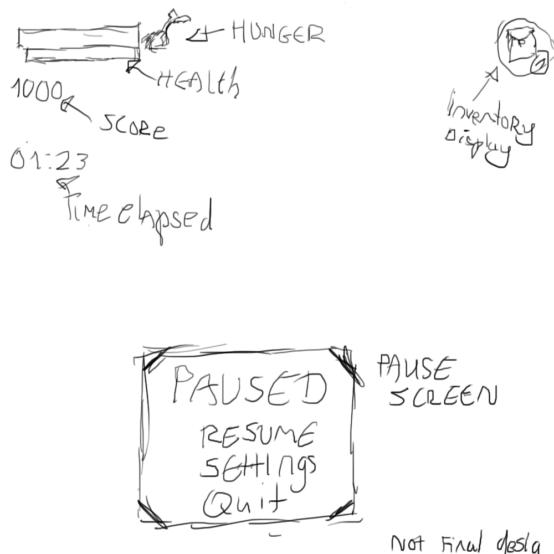

*Simple UI design sketch showing both resources, time elapsed and inventory. In addition to that, the pause menu is also shown. These are not the final designs for these elements.*